**My fellow health care providers,**

**During this trying time, we are confronted by many challenges when caring for our beneficiaries, both those empaneled to us and those in the surrounding remote locations. I am excited to introduce Coast Guard Care Anywhere, a web-based HIPAA secure video visit tool to extend our services to our shipmates during the pandemic and beyond. This tool is critical to our success as the needs for health services increase. To ensure success, I need your help to aggressively adopt this new tool to improve our ability to provide services to our members during the pandemic and also to increase our reach outward into the future. Using the system is as easy as activating the iPad Pro issued to you for Telehealth and reviewing the training available. Your scheduling staff will be provided similar references and training to support your efforts in serving our beneficiaries. Thank you for your continued dedication to the health and wellbeing of our Coast Guard Family.**

**RADM Dana Thomas, Chief Medical Officer**

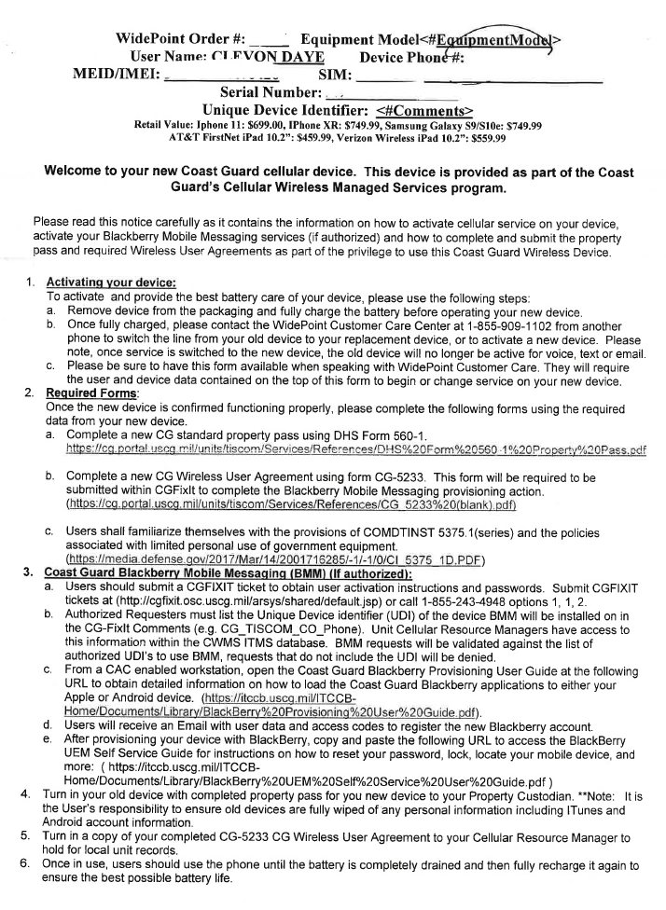

**This document serves as a quick reference/refresher for CG Care Anywhere training. If you have not completed the training, please do so before referring to this document**

|  |  |
| --- | --- |
| **TECHNICAL SUPPORT** | |
| **Technical Support – CG Care Anywhere System** | Technical Support Number (833) 476-6269 or “(833) IronBow” |
| **Technical Support – iPad/hardware** | Contact WidePoint Tech Support:  1-855-909-1102 |

**Using your Coast Guard-issued iPad**

* Make sure you have the documentation that accompanied your device. The top of the document will look similar to this:
* Looking at the very top of the screen, confirm your device is connecting to the **T-Mobile** LTEnetwork (upper left corner) and that your device is registering a signal (e.g. you have bars).



* Open the Internet browser. It is usually “Safari” on Apple products. Click on this icon: 

…then, go to [**https://coastguardcareanywhere.net**](https://coastguardcareanywhere.net). You will be redirected from that site to the vendor log-in page at [**https://virtualhealth.viinetwork.net**](https://virtualhealth.viinetwork.net). Check your activation email (received post-training) for log-in information.



**CG Care Anywhere is web-based; there is no need to download anything to use the application; it can be used on any audio/video-capable device with web access.**

**Managing your schedule**

* Click “**Manage Schedule**” Calendar Icon at top of Dashboard

* Search and select one or more providers under “**Managing Schedule For**”
* Under “Set Up Schedule” tab, click “**Enable Schedule**” toggle
* Populate the fields as appropriate. When complete, hit “**Save Schedule**”

**Managing your appointments**

* Search/Select one or more providers under “**Managing Schedule For**”
* Click “**Manage Appointments**” tab.
* Select date range under “**Show My Appointments For**” and click “**Apply**”

* Select **“Access Appointment,” “Reschedule Appointment,”** or **“Cancel Appointment”** as required